**Exercise: Assertions in Junit**

**Code:**

1. Make a file named, Greet.java and write the following code:

public class Greet{

public String says(){

return "Hello";}

1. Make another file and name it GreetTest.java and write code:

import org.junit.*;

public class GreetTest {

@Test

public void test(){

Greet gre = new Greet();

Assert.assertEquals("Hello, World!", gre.greet());

}

}

1. Install JUnit using Jupiter.

**Output:**

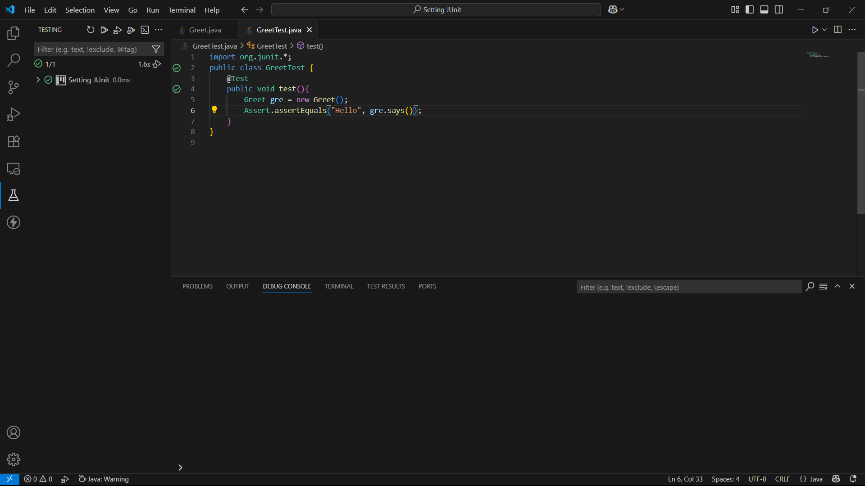

Fig. 1: Shows no errors.

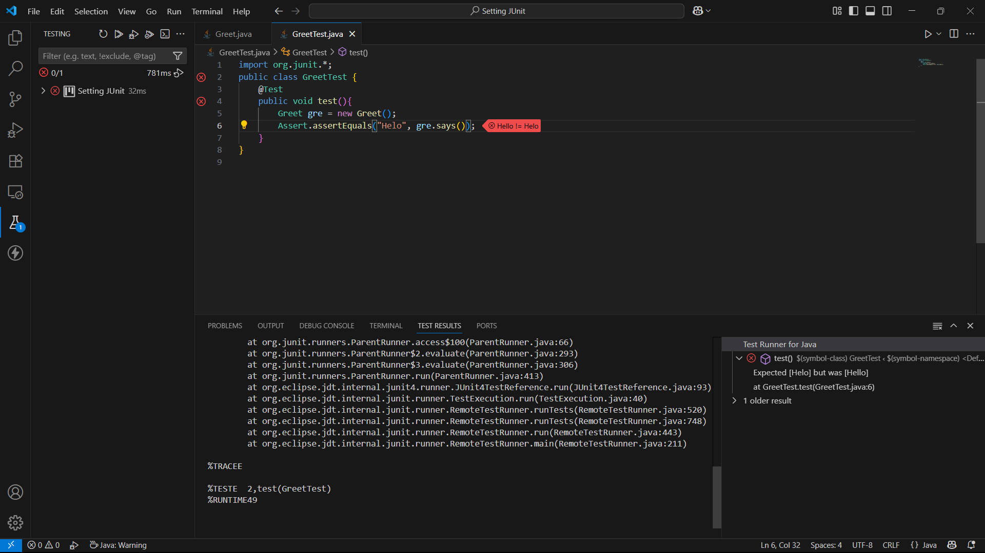

Fig.2: Code with errors.